**AIM**

Compose Electricity bill from user input based on a given tariff using PHP.

**Program Code**

<!DOCTYPE html>

<head>

<title>Calculate Electricity Bill</title>

</head>

<?php

$result_str = $result = '';

if (isset($_POST['unit-submit'])) {

    $units = $_POST['units'];

    if (!empty($units)) {

        $result = calculate_bill($units);

        $result_str = 'Total amount of ' . $units . ' - ' . $result;

    }

}

function calculate_bill($units) {

    $unit_cost_first = 4;

    $unit_cost_second = 5;

    $unit_cost_third = 6;

    if($units <= 100) {

        $bill = $units * $unit_cost_first;

    }

    else if($units > 100 && $units <= 200) {

        $temp = 100 * $unit_cost_first;

        $remaining_units = $units - 100;

        $bill = $temp + ($remaining_units * $unit_cost_second);

    }

    else {

        $temp = (100 * 4) + (100 * $unit_cost_second) + (100 * $unit_cost_third);

        $remaining_units = $units - 200;

        $bill = $temp + $remaining_units ;

    }

    return number_format((float)$bill, 2, '.', '');

}

?>

<body>

<div id="page-wrap">

<h1>Php - Calculate Electricity Bill</h1>

<form action="" method="post" id="quiz-form">

            <input type="number" name="units" id="units" placeholder="Please enter no. of Units" />

            <input type="submit" name="unit-submit" id="unit-submit" value="Submit" />

</form>

<div>

   <?php echo '<br />' . $result_str; ?>

</div>

</div>

</body>

</html>

**Output**

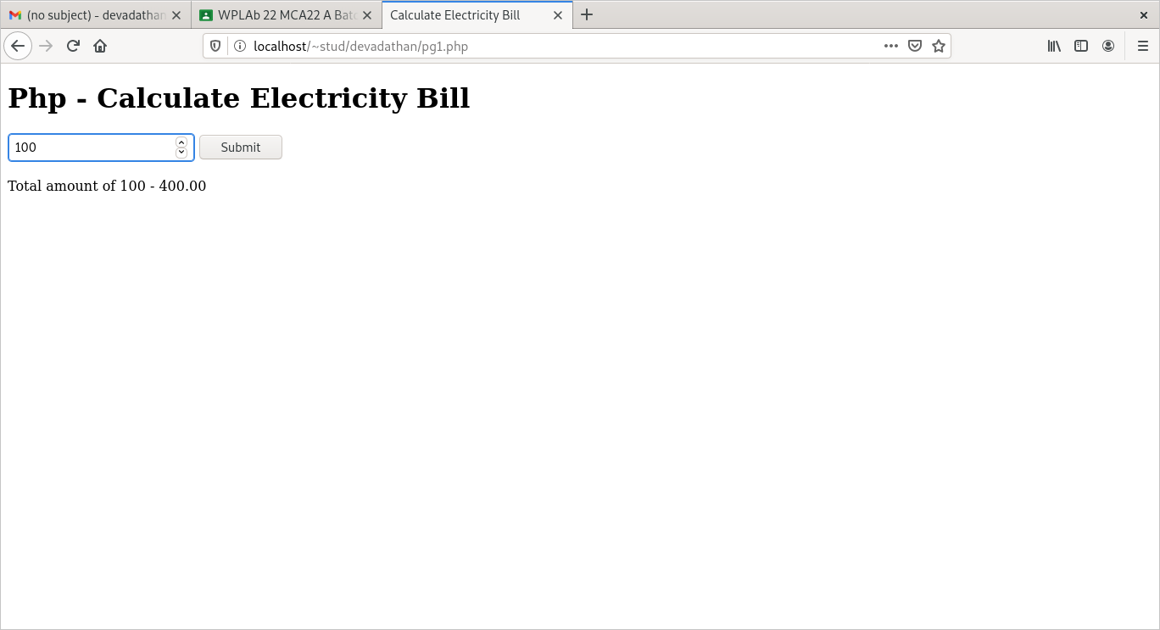

**AIM**

Build a PHP code to store name of students in an array and display it using print_r  
function. Sort and Display the same using asort & arsort functions.

**Program Code**

**STUD.PHP**

<html>

<head>

<title>stud</title>

</head>

 <body bgcolor="#ccddff">

<form  action="stud1.php" method="post">

NAME 1:<input type=text name=fname placeholder="enter student name"><br>

NAME 2:<input type=text name=fname1 placeholder="enter student name"><br>

NAME 3:<input type=text name=fname2 placeholder="enter student name"><br>

NAME 4:<input type=text name=fname3 placeholder="enter student name"><br>

NAME 5:<input type=text name=fname4 placeholder="enter student name"><br>

<input type="submit" name="submit">

<input type="reset" name="reset">

</form>

</body>

</html>

**STUD1.PHP**

<html>

   <head>

      <title>Student Name</title>

      <style>

         body{

         padding-top:70px;

         }

      </style>

   </head>

   <body align="center"bgcolor="#ccddff">

      <?php

         if (isset($_POST['submit']))

              {

             $name [0] = $_POST['fname'];

             $name [1] = $_POST['fname1'];

             $name [2]= $_POST['fname2'];

             $name [3]= $_POST['fname3'];

             $name [4]= $_POST['fname4'];

             echo "Names :";

             print_r($name);

             echo"<br>";

             echo"Names in ascending order :";

             asort($name);

             print_r($name);

             echo"<br>";

             echo"Names in descending order :" ;

             arsort($name);

             print_r($name);

         }

         ?>

   </body>

</html>

**Output**

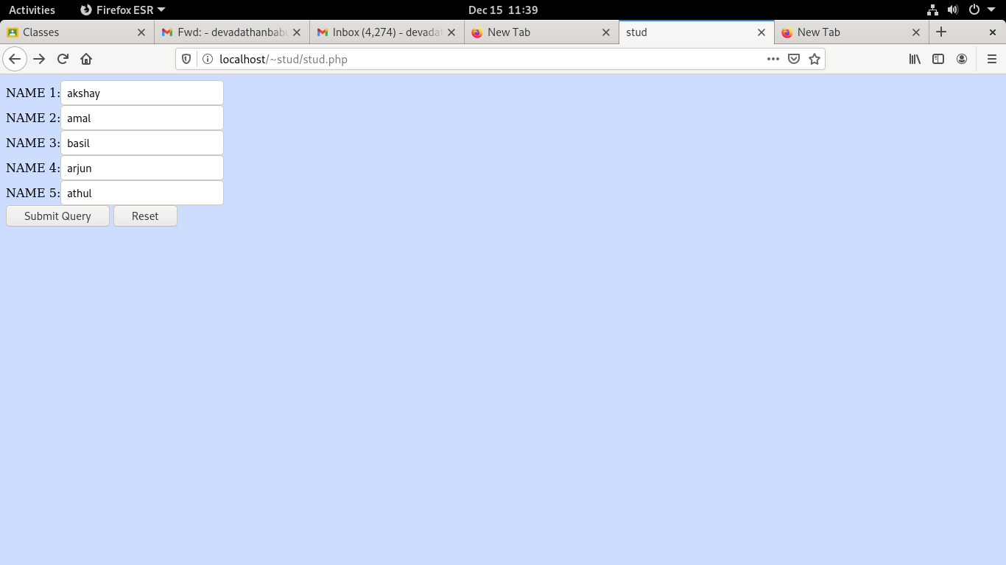

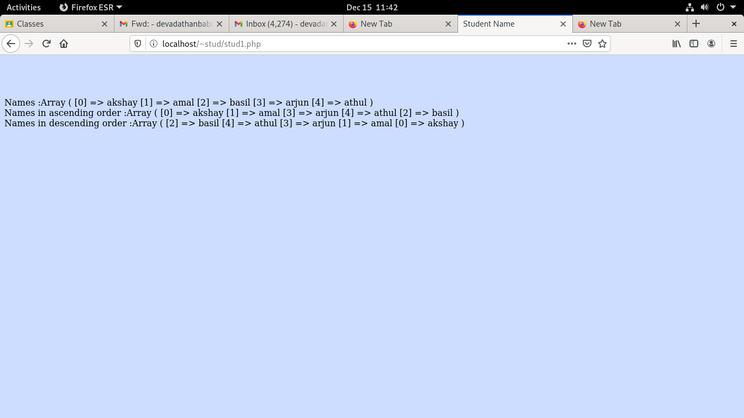

**AIM**

Build a PHP code to store name of Indian Cricket players in an array and display  
the same in HTML table.

**Program Code**

**CRICKET.PHP**

<html>

<head>

<title>stud</title>

<style>

h1{

text-shadow:0 0 2px red;

}

</head>

</style>

 <body align="center" bgcolor="#ccddff">

 <h1 align="center" >CRICKET PLAYERS</h1>

<table align="center" border-collapse="collapse" border="1">

<form  action="p1.php" method="post">

<tr>

<th>NAME 1:</th>

<td><input type=text name=p placeholder="enter cricket players name"></td>

</tr>

<tr>

<tH>NAME 2:</th>

<td><input type=text name=p1 placeholder="enter cricket players name"></td>

</tr>

<tr>

<th>NAME 3:</th>

<td><input type=text name=p2 placeholder="enter cricket players name"></td>

</tr>

<tr>

<th>NAME 4:</th>

<td><input type=text name=p3 placeholder="enter cricket players name"></td>

</tr>

<tr>

<th>NAME 5:</th>

<td><input type=text name=p4 placeholder="enter cricket players name"></td>

</tr>

<tr>

<td><input type="submit" name="submit">&nbsp&nbsp&nbsp

<input type="reset" name="reset"></td>

</tr>

</form>

</table>

</body>

</html>

**P1.PHP**

<?php

$names[0]=$_POST['p'];

$names[1]=$_POST['p1'];

$names[2]=$_POST['p2'];

$names[3]=$_POST['p3'];

$names[4]=$_POST['p4'];

$length=count($names);

echo "<h2 align='center'>Indian Cricket Players.</h2>";

echo "<table border='1' align='center' bgcolor='#ccffff'>";

echo "<tr>";

echo "<th width='100'>Sl.No.</th>";

echo "<th width='100'>Name</th>";

echo "</tr>";

for($i=0;$i<$length;$i++)

{

echo "<tr>";

echo "<td>".($i+1)."</td>";

echo "<td>".$names[$i]."</td>";

echo "</tr>";

}

echo "</table>";

?>

**Output**

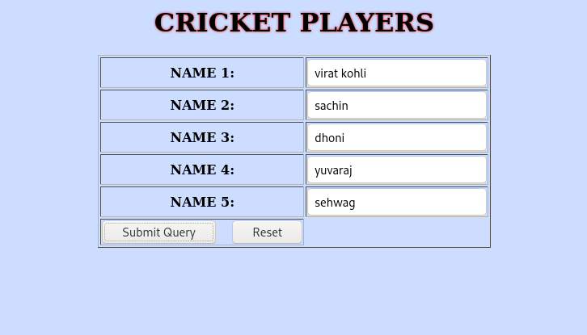

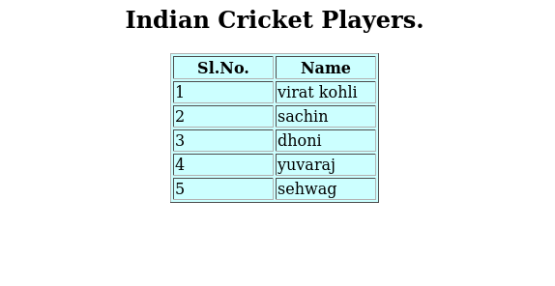

**AIM**

Outline a registration form using PHP and do necessary validations.

**Program Code**

<?php

$name = $email= $gender = $address= $phone= $gender= "";

$name1= $email1= $gender1= $address1= $phone1= $gender1= "";

if (isset($_POST["submit"]))

{

  if (empty($_POST["fname"]))

   {

    $name = "Name is required";

   }

  else

   {

    $name1 = $_POST["fname"];

    }

   if (empty($_POST["email"]))

   {

    $email= "Email is required";

   }

   else

   {

    $email1= $_POST["email"];

    }

   if (empty($_POST["address"]))

   {

    $address = "Address is required";

   }

   else

   {

    $address1= $_POST["address"];

    }

   if (empty($_POST["gender"]))

   {

    $gender = "Gender is required";

   }

  else

   {

    $gender1 = $_POST["gender"];

    }

   if (empty($_POST["phone"]))

   {

    $phone= "phone is required";

   }

else

   {

    $phone1 = $_POST["phone"];

    }

}

?>

<html>

<head>

<style>

h1{

text-shadow:0 0 3px red;

}

table

{

border-collapse:collapse;}

td{

         padding:15px;

}

</style>

</head>

<center>

<body bgcolor="#ccffff">

<table border="1" bgcolor="#ccddff">

<form method="post" action="#">

<h1>REGISTRATION FORM</h1><br>

<tr>

<td>Name :<input type="text" name="fname"></td>

<td><span class="error"><?php echo $name;?></span></td>

</tr>

<tr>

<td>Email :<input type="text" name="email"></td>

<td><span class="error"><?php echo $email;?></span></td>

</tr>

<td>Gender : <input type="radio" name="gender" value="male">Male

<input type="radio" name="gender" value="female">Female</td>

<td><span class="error"><?php echo $gender;?></span></td>

</tr>

<tr>

<td>Phone : <input type="text" name="phone"></td>

<td><span class="error"><?php echo $phone;?></span> </td>

</tr>

<tr>

<td>Address :<textarea rows="4" cols="20" name=address></textarea></td>

<td><span class="error"><?php echo $address;?></span></td>

</tr>

<td><center><input type="submit" name="submit" value="submit">

<input type="reset" name="reset" value="reset"></center></td></tr>

</table>

</form>

<?php

    if(isset($_POST['submit'])) {

    if($name == "" && $email== "" && $phone == "" && $gender== "" && $address == "")

    {

        echo "<h3 color = #ccffdd> <b>You have sucessfully registered.</b> </h3>";

        echo "<h2>Your Input:</h2>";

        echo "Name: " .$name1;

        echo "<br>";

        echo "Email: " .$email1;

        echo "<br>";

        echo "Phone No: " .$phone1;

        echo "<br>";

        echo "Address: " .$address1;

        echo "<br>";

        echo "Gender: " .$gender1;

    } else {

        echo "<h3> <b>You didn't filled up the form correctly.</b> </h3>";

    }

    }

?>

</body>

</html>

**Output**

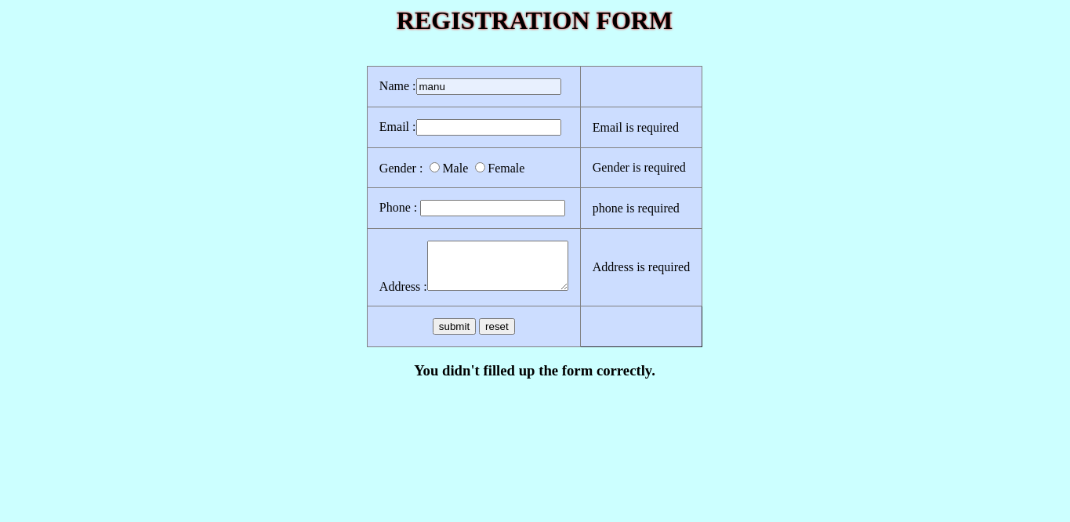

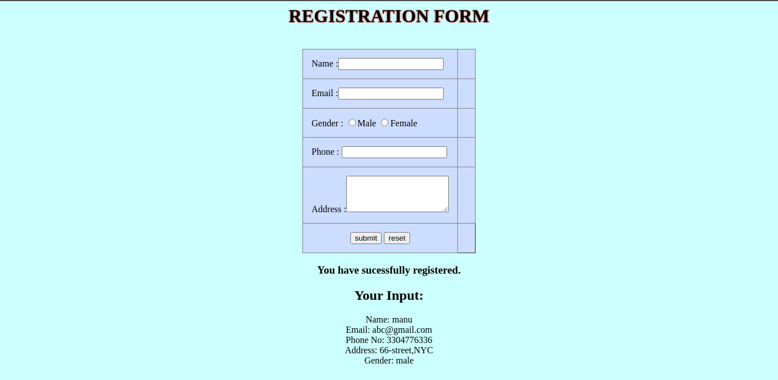

**AIM**

Develop a PHP program to connect to a database and add data to the employee table and retrieve data from the table and show the retrieved details in a neat format.

**Program Code**

**Cont.php**

<html>

<head>

<style>

h1{

text-shadow:0 0 3px red;

}

table

{

border-collapse:collapse;}

td{

         padding:15px;

}

</style>

</head>

<center>

<body bgcolor="#ccffff">

<table border="1" bgcolor="#ccddff">

<form method="post" action="#">

<h1>REGISTRATION FORM</h1><br>

<tr>

<td>EMPLOYEE ID:</td><td><input type="number" name="id"></td>

</tr>

<tr>

<td>EMPLOYEE NAME:</td><td><input type="text" name="fname"></td>

</tr>

<td>AGE:</td><td> <input type="number" name="age" </td>

</tr>

<tr>

<td>DEPARTMENT :</td><td> <input type="text" name="dept"></td>

</tr>

<td><center><input type="submit" name="submit" value="submit">

<input type="reset" name="reset" value="reset"></center></td></tr>

</table>

</form>

<form name=home method="POST" action="html.php">

<button>HOME</button>

</form>

</body>

</html>

<?php error_reporting(0); ?>

<?php

$n1 = $_POST["id"];

$n2 = $_POST["fname"];

$n3 = $_POST["age"];

$n4 = $_POST["dept"];

if (isset($_POST["submit"]))

{

$servername = "localhost";

$username = "fisat";

$password = "fisat";

// Create connection

$conn = new mysqli($servername, $username, $password,"fisatdb");

// Check connection

if ($conn->connect_error) {

  die("Connection failed: " . $conn->connect_error);

}

echo "Connected successfully";

$sql = "INSERT INTO employee(emp_id,emp_name,age,dept ) VALUES($n1,'$n2',$n3,'$n4')";

if ($conn->query($sql) === true) {

echo 'New row added.';

} else {

echo "ERROR: Could not execute query:";

}

$conn->close();

}

?>

**ret.php**

<?php

$con = new mysqli("localhost", "fisat", "fisat", "fisatdb");

if ($con=== false) {

die("ERROR: Could not connect. " . mysqli_connect_error());

}

$sql = "SELECT * FROM employee";

if ($result = $con->query($sql))

{ if ($result->num_rows > 0) {

 ?>

<html>

<body align="center">

<table border=1 align="center">

<tr>

<th>Employee ID</th><th>Employee Name</th><th>Employee Department</th><th>Employee Age</th>

</tr>

<tr>

<?php while($row = $result->fetch_array()) { ?>

<td><?php echo $row[0]; ?> </td><td><?php echo $row[1];?></td><td><?php echo $row[2];?></td><td><?php echo $row[3];?></td>

</tr>

<?php

} ?>

</table>

<form name=home method="POST" action="html.php">

<button>HOME</button>

</form>

</body>

</html>

<?php

$result->close();

} else {

echo "No records matching your query were found.";

}

} else {

echo "ERROR: Could not execute $sql. " . $con->error;

} $con->close();

?>

**html.php**

<html>

<head>

<title>homepage</title>

</head>

<body align="center">

<h2>Employee Registration</h2>

<form name=registation method="POST" action="cont.php">

<button>REGISTER</button>

</form>

<form name=reg method="POST" action="ret.php">

<button>VIEW</button>

</form>

</body>

</html>

**Output**



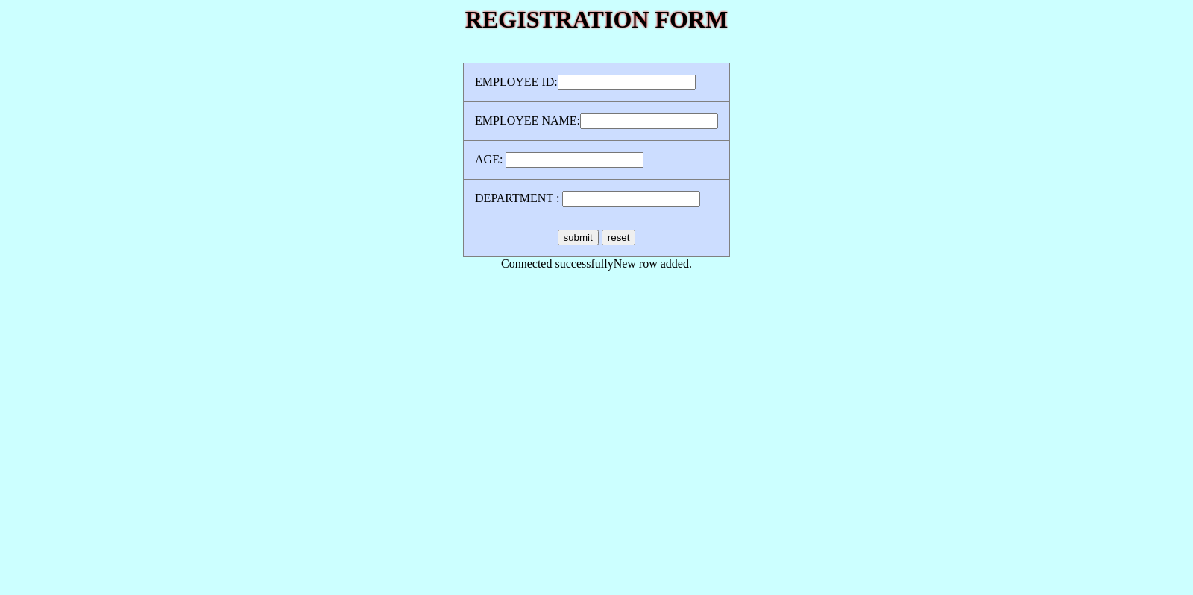

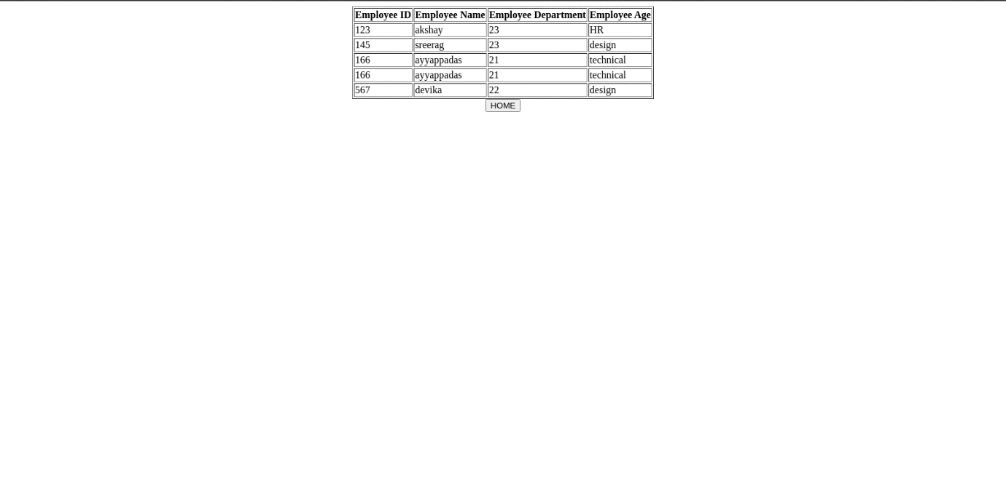

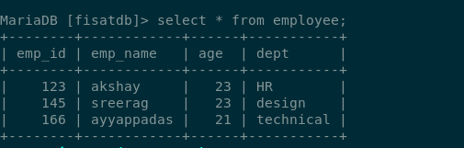

**AIM**

Using PHP and MySQL, develop a program to accept book information viz. Accession number, title, authors, edition and publisher from a web page and store the information in a database and to search for a book with the title specified by the user and to display the search results with proper headings.

**Program Code**

**html.php**

<html>

<head>

<title>homepage</title>

</head>

<body align="center">

<h2>BOOK DETAILS</h2>

<form name=registation method="POST" action="cont.php">

<button>Add Book Details</button>

</form>

<form name=reg method="POST" action="ret.php">

<button>VIEW</button>

</form>

<form name=search method="POST" action="search.php">

<button>SEARCH</button>

</form

</body>

</html>

**Cont.php**

<html>

<head>

<style>

h1{

text-shadow:0 0 3px red;

}

table

{

border-collapse:collapse;}

td{

         padding:15px;

}

</style>

</head>

<center>

<body bgcolor="#ccffff">

<table border="1" bgcolor="#ccddff">

<form method="post" action="#">

<h1>ENTER BOOK DETAILS</h1><br>

<tr>

<td>Accession_number:</td><td><input type="number" name="acno"></td>

</tr>

<td>Title:</td><td> <input type="text" name="title" </td>

</tr>

<tr>

<td>Author :</td><td> <input type="text" name="au"></td>

</tr>

<tr>

<td>Edition :</td><td> <input type="number" name="edi"></td>

</tr>

<tr>

<td>Publisher :</td><td> <input type="text" name="pub"></td>

</tr>

<td><center><input type="submit" name="submit" value="submit">

<input type="reset" name="reset" value="reset"></center></td></tr>

</table>

</form>

<form name=home method="POST" action="html.php">

<button>HOME</button>

</form>

</body>

</html>

<?php error_reporting(0); ?>

<?php

$n1 = $_POST["acno"];

$n2 = $_POST["title"];

$n3 = $_POST["au"];

$n4 = $_POST["edi"];

$n5 = $_POST["pub"];

if (isset($_POST["submit"]))

{

$servername = "localhost";

$username = "fisat";

$password = "fisat";

// Create connection

$conn = new mysqli($servername, $username, $password,"fisatdb");

// Check connection

if ($conn->connect_error) {

  die("Connection failed: " . $conn->connect_error);

}

echo "Connected successfully";

$sql = "INSERT INTO book(accs_no,title,author,edition,publisher ) VALUES($n1,'$n2','$n3',$n4,'$n5')";

if ($conn->query($sql))

{

echo 'New row added.';

} else

{

echo "ERROR: Could not execute query:";

}

$conn->close();

}

?>

**ret.php**

<?php

$con = new mysqli("localhost", "fisat", "fisat", "fisatdb");

if ($con=== false) {

die("ERROR: Could not connect. " . mysqli_connect_error());

}

$sql = "SELECT * FROM book ";

if ($result = $con->query($sql))

{ if ($result->num_rows > 0) {

 ?>

<html>

<body align="center">

<table border=1 align="center">

<tr>

<th>Accession_number</th><th>Title</th><th>Author</th><th>Edition</th><th>Publisher</th>

</tr>

<tr>

<?php while($row = $result->fetch_array()) { ?>

<td><?php echo $row[0]; ?> </td><td><?php echo $row[1];?></td><td><?php echo $row[2];?></td><td><?php echo $row[3];?></td><td><?php echo $row[4];?></td>

</tr>

<?php

} ?>

</table>

<form name=home method="POST" action="html.php">

<button>HOME</button>

</form>

</body>

</html>

<?php

$result->close();

} else {

echo "No records matching your query were found.";

}

} else {

echo "ERROR: Could not execute $sql. " . $con->error;

} $con->close();

?>

**search.php**

<html>

<head>

<title>search</title>

</head>

<body>

<form name="frm2" action="search1.php" method="POST">

<center>

<b><u>SEARCH BOOK</u></b><br>

TITLE<input type="text" name="title"><br>

<input type="submit" name="Submit">

</center>

</form>

</body>

</html>

**search1.php**

<?php

$n2=$_REQUEST['title'];

$con=new mysqli("localhost","fisat","fisat","fisatdb");

if($con==false)

{

echo "Failed to connect";

}

?>

<html><h1 align="center">BOOK DETAILS</h1>

<?php

$sql="SELECT * FROM book where title='$n2'";

if($result=$con->query($sql))

{

if($result->num_rows>0)

{

echo"<table border=1 align='center'>";

echo " <tr> <th>Accession Number</th><th>Title</th> <th>Author</th> <th>Edition</th>  <th>Publisher</th></tr>";

while($row=$result->fetch_array())

{

echo"<tr>

<td>$row[0]</td>

<td>$row[1]</td>

<td>$row[2]</td>

<td>$row[3]</td>

<td>$row[4]</td>

</tr>";

}

$result->close();

}

}

else

{

echo "\nCould not found ";

}

?>

**Output**



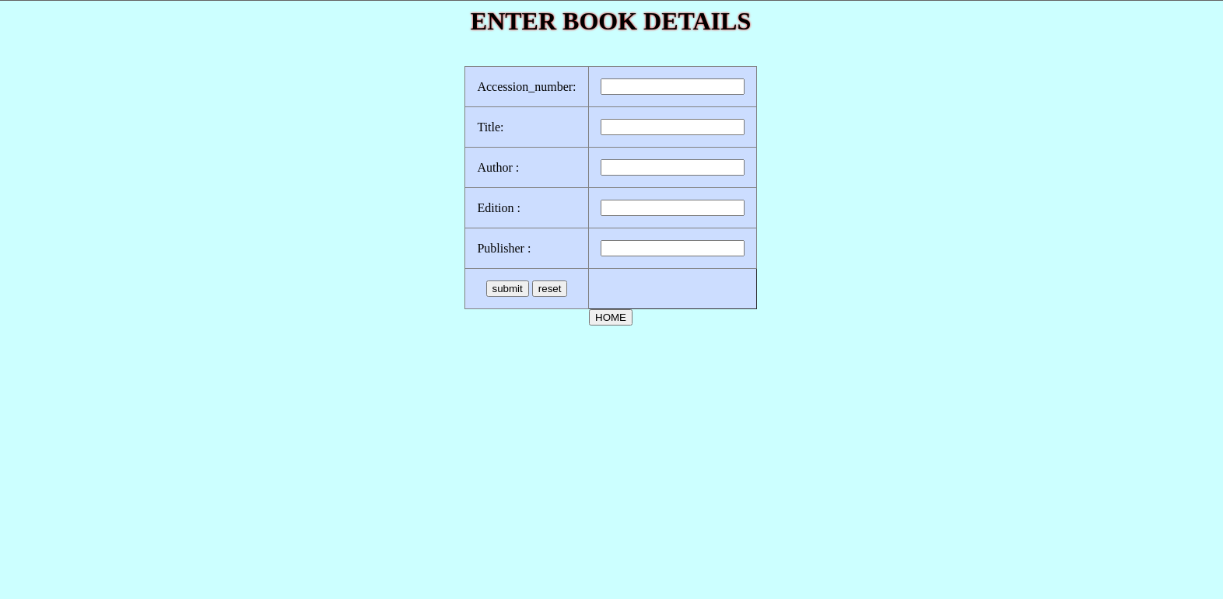







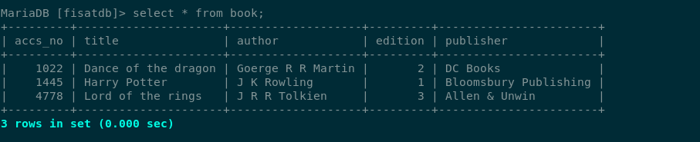

**AIM**

Using PHP and MySQL, develop a program to collect airline details and display all the airlines between a particular source and destination.

**Program Code**

**Home.php**

<html>

<head>

<title>homepage</title>

</head>

<body align="center">

<h2>AIRLINE INFORMATION SYSTEM</h2>

<form name=registation method="POST" action="air.php">

<button>ADD AIRLINE DETAILS</button>

</form>

<form name=reg method="POST" action="ret.php">

<button>VIEW</button>

</form>

<form name=search method="POST" action="search.php">

<button>SEARCH AIRLINE DETAILS</button>

</form

</body>

</html>

**air.php**

<html>

<head>

<style>

h1{

text-shadow:0 0 3px red;

}

table

{

border-collapse:collapse;}

td{

         padding:15px;

}

</style>

</head>

<center>

<body bgcolor="#ccffff">

<table border="1" bgcolor="#ccddff">

<form method="post" action="#">

<h1>ENTER AIRLINE DETAILS</h1><br>

<tr>

<td>AIRLINE_ID:</td><td><input type="number" name="id"></td>

</tr>

<td>AIRLINENAME:</td><td> <input type="text" name="name" </td>

</tr>

<tr>

<td>DEPARTURE FROM :</td><td> <input type="text" name="df"></td>

</tr>

<tr>

<td>DEPARTURE TIME :</td><td> <input type="time" name="dt"></td>

</tr>

<tr>

<td>AIR TIME :</td><td> <input type="number" name="at"></td>

</tr>

<tr>

<td>AIR PLACE :</td><td> <input type="text" name="ap"></td>

</tr>

<td><center><input type="submit" name="submit" value="submit">

<input type="reset" name="reset" value="reset"></center></td></tr>

</table>

</form>

<form name=home method="POST" action="home.php">

<button>HOME</button>

</form>

</body>

</html>

<?php error_reporting(0); ?>

<?php

$n1 = $_POST["id"];

$n2 = $_POST["name"];

$n3 = $_POST["df"];

$n4 = $_POST["dt"];

$n5 = $_POST["at"];

$n6 = $_POST["ap"];

if (isset($_POST["submit"]))

{

$servername = "localhost";

$username = "fisat";

$password = "fisat";

// Create connection

$conn = new mysqli($servername, $username, $password,"fisatdb");

// Check connection

if ($conn->connect_error) {

  die("Connection failed: " . $conn->connect_error);

}

echo "Connected successfully";

$sql = "INSERT INTO airline( airline_id,airline_name,depfrom,deptime,airtime,airplace) VALUES($n1,'$n2','$n3','$n4',$n5,'$n6')";

if ($conn->query($sql))

{

echo 'New row added.';

} else

{

echo "ERROR: Could not execute query:";

}

$conn->close();

}

?>

**ret.php**

<?php

$con = new mysqli("localhost", "fisat", "fisat", "fisatdb");

if ($con=== false) {

die("ERROR: Could not connect. " . mysqli_connect_error());

}

$sql = "SELECT * FROM airline";

if ($result = $con->query($sql))

{ if ($result->num_rows > 0) {

 ?>

<html>

<body align="center">

<table border=1 align="center">

<tr>

 <th>AIRLINE_ID</th><th>AIRLINENAME</th> <th>DEPARTURE FROM</th> <th>DEPARTURE TIME</th>  <th>AIR TIME </th> <th>AIR PLACE </th>

</tr>

<tr>

<?php while($row = $result->fetch_array()) { ?>

<td><?php echo $row[0]; ?> </td><td><?php echo $row[1];?></td><td><?php echo $row[2];?></td><td><?php echo $row[3];?></td><td><?php echo $row[4];?><?php echo $row[5]; ?></td>

</tr>

<?php

} ?>

</table>

<form name=home method="POST" action="home.php">

<button>HOME</button>

</form>

</body>

</html>

<?php

$result->close();

} else {

echo "No records matching your query were found.";

}

} else {

echo "ERROR: Could not execute $sql. " . $con->error;

} $con->close();

?>

**search.php**

<html>

<head>

<title>search</title>

</head>

<body align="center">

<b>SEARCH AIRLINE</b>

<table align="center"border="1" bgcolor="#ccddff">

<form name="frm2" action="search1.php"method="POST">

<center>

<tr>

<td>

DEPARTURE FROM:</td><td><input type="text" name="txt"></td>

</tr>

<tr>

<td>

ARIVAL PLACE:</td><td><input type="text" name="txt1"></td></tr>

<tr><td>

<input type="submit" name="Submit"></td></tr>

</center>

</form>

</table>

<form  name=home method="POST" action="home.php">

<button>HOME</button>

</form>

</body>

</html>

**search1.php**

<?php

$n3 = $_POST['txt'];

$n6 = $_POST['txt1'];

$con=new mysqli("localhost","fisat","fisat","fisatdb");

if($con==false)

{

echo "Failed to connect";

}

?>

<html><h1 align="center">AIRLINE DETAILS</h1>

<?php

$sql="SELECT * FROM airline where depfrom='$n3' and airplace='$n6'";

if($result=$con->query($sql))

{

if($result->num_rows>0)

{

echo"<table border=1 align='center'>";

echo " <tr> <th>AIRLINE_ID</th><th>AIRLINENAME</th> <th>DEPARTURE FROM</th> <th>DEPARTURE TIME</th>  <th>AIR TIME </th> <th>AIR PLACE </th></tr>";

while($row=$result->fetch_array())

{

echo"<tr>

<td>$row[0]</td>

<td>$row[1]</td>

<td>$row[2]</td>

<td>$row[3]</td>

<td>$row[4]</td>

<td>$row[5]</td>

</tr>";

}

?>

<html><body>

</table>

<form name=home method="POST" action="home.php">

<button>HOME</button>

</form>

</body>

</html>

<?php

$result->close();

}

}

else

{

echo "\nCould not found ";

}

?>

**Output**

